Judith Barrios

06/21/24

ITAI 1378 Computer Vision

Patricia McManus

My Journal on SVM

SVM:

Support Vector Machines are supervised learning models that can be used in classification and regression duties. Classification is used to predict class labels, such as Real or False, Male or Female, etc. Meanwhile regression is used to determine continuous values like price, income, etc. (Sarangam, 2). SVM is divided into three main concepts, one of them is hyperplane, which divides input spaces into sections, meaning it differentiates the two classes. Another one is the support vector, which are the points closer to the hyperplane in the separating line, they help the margin that is the distance between the hyperplane and the points. Support Vector Machines in image classification helps by finding the voluntary hyperplane that will best separate the classes of images in feature spaces. You would first have to select the appropriate kernel function based on the model and then define the parameters and constraints. It can effectively handle high-dimensional data like images, “it maps data to a high dimensional feature space, then the points are categorized that the data is transformed in a way that the separator can be drawn as hyperplanes.” (How SVM Works, 3). Then we would make predictions based on the models and structure brilliant thoughts from it. There are many benefits like the bigger the numbers of the features the more potential it has to succeed with SVM, it has efficient memory to save all your data, and includes many kernels like linear, polynomial, and radial basis function. Kernel determines the types of hyperplanes that are divide in the data, we use linear kernel when the data can be divided by a straight line, it is simple and easy to use. Polynomial kernel on the other hand is a nonlinear function that transfers polynomial combinations and it is very effective, while radial basis function is not linearly separable, but it can capture nonlinear relationships between inputs, giving it wide ranges of applications. By transforming images into feature vectors like Histogram of Oriented Gradients, SVMs can more accurately classify images into the right categories based on their unique characteristics, making them a powerful choice in the field.

Steps:

    The preparation steps to get started on the lab were to first download the file into the Jupyter notebook and importing the libraries such as, numpy, matplotlib, tensorflow, and scikit-learn. You can install all these at the same time using “!pip install’, then you import each library and simplify it in a smaller format name. We then download the CIFAR-10 dataset located in the keras library, and convert the images to grayscale using “X_train_gray” and test method. We would use the flatten() feature to flatten the labels as well, and display a sample image to see how it looks like by inputting “ply.imshow()” and “ply.title()”. “Plt.show()” displays the image we flatten and grey scaled, after that we learn about SVM and how it contributes to classification. We basically apply it to the model to find the hyperplane so we can make a prediction and see the accuracy of the model. We train the models on SVM classifier by classifying them based on their extracted features. We add features to predict on our images and print the accuracy and classification report to show us everything of the images, giving us the evaluation process. From all these steps we can make adjustments and try out new methods, later making our final conclusion and summarize what we have learned from the images and model.

Problems:

     Some problems I faced during the lab, was understanding everything clearly, because some parts were confusing like the predictions, so I had to reread the codes and information various times and took some time to see how Jupyter works. I also found it difficult to get the exact code right, because one little mistake and the code won’t work, and can cause headaches, but by carefully checking over your work and being patient it can do great things. Building your own dataset is more complex and requires more time, and planning, because you are doing it step by step, your creating it out of less information and have to think more about it. While note book working is more easier, because it contains examples and is like a guide to follow along, it helps expand the mind and makes it easier to understand.

Concepts:

    The labs concept was well and clear to understand, because you learned how to import all sort of libraries onto the Jupyter notebook, which is useful for every new notebook you will create. Installing libraries is critical in order to enable language capabilities and enhance various tasks, they provide a lot of tools and modules to make it easier for the developer to work. We also learned how to classify images using support vector machines, which are a supervised machine algorithm that helps classify data using a hyperplane that determines the distance between the classes. We should use SVM, because they are effective in high dimensional spaces, do great at classifying nonlinear data, have capacity control, etc. The lab can change the images color and present different results depending on what you want, it is very useful to practice and learn some techniques. The lab can give reports, train models, and make predictions, and also flatten and color them grey to be used as features. SVC is located in the Scikit-Learn library and is used to apply SVM algorithms, while kernel defines the types of hyperplane used in the data. These tools are easy to classify images and do better performance on the data. The results of the lab are a good start and the images are decent looking for the few things we did, which were flatting it and making it grey. There are many other possibilities to get a higher accuracy of the model, that later the model can identify different objects by training it better and testing it more. In conclusion we can find combinations of hyper parameters that result in higher performance and accuracy from the model.

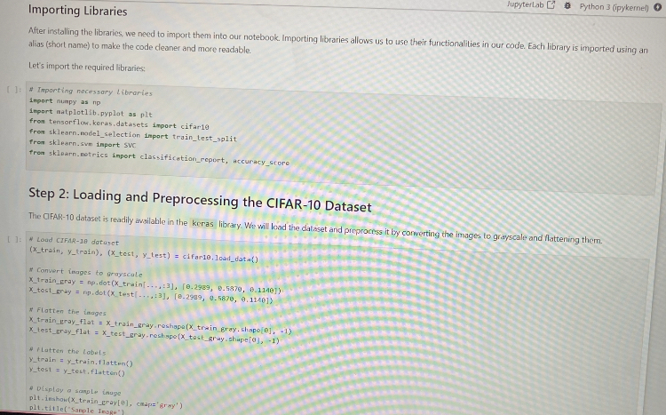

* This image displays how one should import the libraries and the preprocess on how to make the images greyscale and flatten.

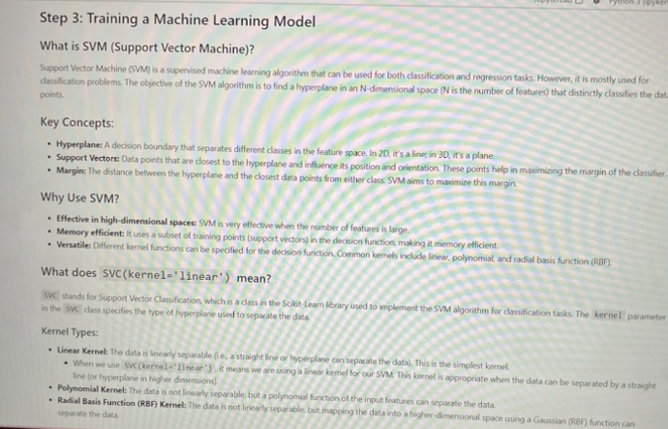

* This image explains what is SVM, how it works and why it is useful to have it.
* 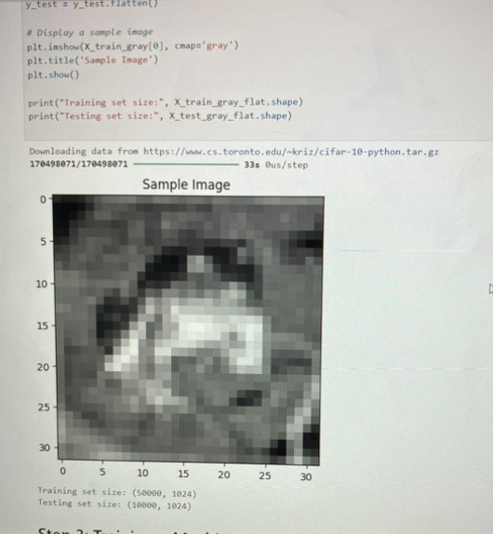This image displays the sample image after it has been trained and tested.

Work Cited:

Sarangam, Ajay. “Classification vs Regression: An Easy Guide in 6 Points.” UNext, 7 Mar. 2023, u-next.com/blogs/artificial-intelligence/classification-vs-regression/#:~:text=The%20key%20distinction%20between%20Classification,Spam%20or%20Not%20Spam%2C%20etc.

“17.3 Advantages and Disadvantages of SVM.” MyEducator, app.myeducator.com/reader/web/1421a/17/so0pv/. Accessed 21 June 2024.

“Major Kernel Functions in Support Vector Machine (SVM).” GeeksforGeeks, GeeksforGeeks, 7 Feb. 2022, [www.geeksforgeeks.org/major-kernel-functions-in-support-vector-machine-svm/](http://www.geeksforgeeks.org/major-kernel-functions-in-support-vector-machine-svm/)

“How SVM Works.” How SVM Works, 18 Aug. 2021, [www.ibm.com/docs/en/spss-modeler/saas?topic=models-how-svm-works](http://www.ibm.com/docs/en/spss-modeler/saas?topic=models-how-svm-works)